Henry Bradlow
Final Project

Abstract:
I set out to create a cloth simulator that would be stable under reasonable time steps and be able to model cloth draped over a sphere. My biggest challenge was finding a good model for interacting with a rigid sphere. I explored two different methods and found that displacing masses to points outside the sphere is more stable than applying a repulsive force away from the sphere's center.

Introduction:
Cloth simulation is very important in computer graphics as much of what is needed to be rendered consists of human scenes. I am interested in simulation and numerical methods of integration so I chose this project to learn more about the field.

Method:

Numerical Integration:
I began by modeling simple masses connected by springs. To evaluate the movement of the masses over time, I first used forwards (explicit) Euler's method, but this provided very unstable solutions. With only a few masses, the system already exhibited qualities of instability and the total energy of the system rapidly grew when masses were disturbed.
My initial solution to this problem was an artificial dampening force added to each mass proportional to its velocity. This did not solve the problem, however, and it introduced new problems, such as damned gravity. Under this scheme, the system was still unstable unless a very large dampening force was applied, but this did not look physical.
My second solution to the instability was to use a better evaluation method: backwards (implicit) Euler's method. The goal was to calculate the next time step's position based off of the next time step's velocity. This method is much more stable than forwards Euler for springs because a spring force is a restoring force. Using forwards Euler's method consistently overestimates the velocity and energy of each particle leading to unstable systems. Using backwards Euler's method, however, consistently underestimates the velocity and energy of each particle leading to stable solutions. Although both schemes introduce errors, the latter tends to cause the system to “dampen” rather than “explode”, and this dampening often appears physical.

For backwards Euler, the goal is the following implicit formula, where f is a function of position and velocity.
This formula is impossible to compute, so I used an iterative method to approximate this value.
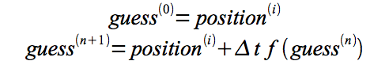
This method began by guessing a plausible value for the next position, and then refines the value by applying the guess to the implicit formula. A very stable solution was found by iterating this process fifty times.
This numerical integration technique allowed me to effectively model spring and mass systems that were stable under significant disturbance.

Cloth Modeling:
I began by modeling a 25 by 25 mesh of masses connected by springs to their eight nearest neighbors.

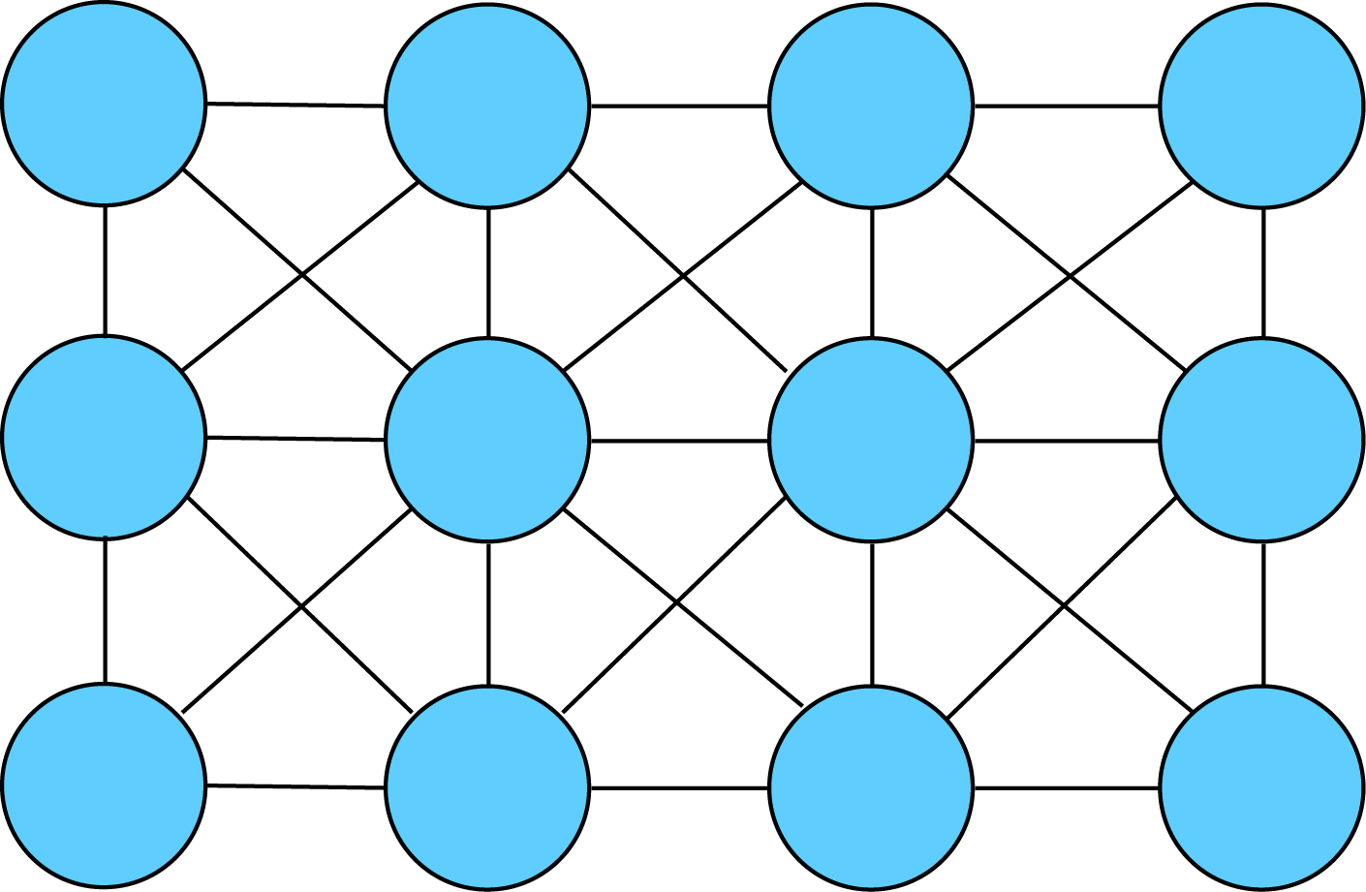

This system worked well but it lacked stiffness and it produced sheets that looked much too loose to be cloth. The solution to this problem was the addition of more springs that spanned multiple masses.
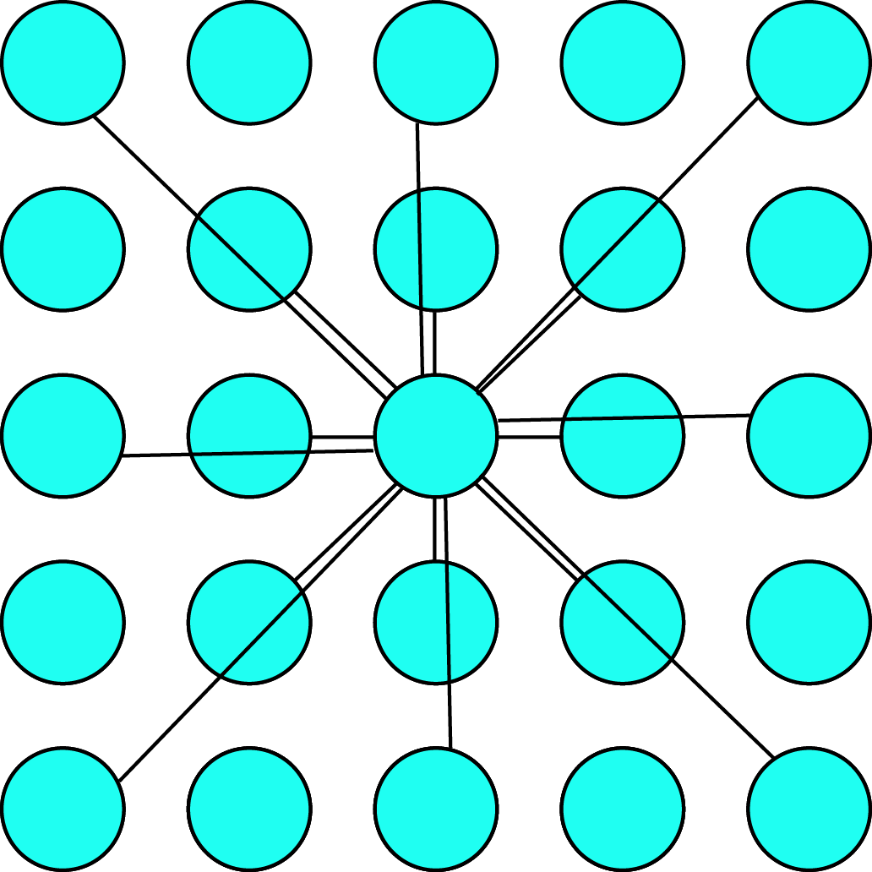
This system allows the user to very easily change the properties of the cloth by changing the relative spring constants of the outer set of springs with respect to the inner set of springs.

Sphere intersection:
Method 1: Repulsion
The most difficult part of the simulation was dealing with intersection with a rigid body, and I implemented many different methods. The first method used was a simple reflection off of the surface of a sphere in the direction of the surface normal.

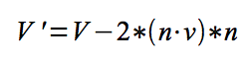
This had many problems and did not look physics. The first problem was that it bounced off of the surface upon impact. My solution to this problem was to modify the reflection formula and only cancel the normal component rather than reflecting it back.
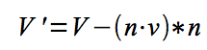
This produced the desired effect of the cloth hitting the sphere and stopping. This method, however, introduced another problem with numerical inaccuracies. Due to accumulated error over time, the cloth would slowly sink into the sphere due to gravity. I addressed this problem by applying a small constant repulsive force to the cloth if it entered the sphere.
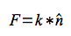
While this effectively prevented the problem of the cloth slipping through the sphere, it again produced visually unconvincing results. Not only would the cloth bounce off upon initial impact, but it would also continue to bounce even after settling. When I tried to reduce the repulsive force, I could not make it low enough to get rid of the bouncing problem without the cloth sinking into the sphere. My solution was to increase the force by an amount inversely proportional to the distance from the center of the sphere raised to a power.
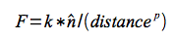
By choosing the correct power, this method produced visually convincing results.

This method worked well for stationary spheres, but became unstable when the sphere moved. This was caused by the sphere moving through the cloth on a discrete time step and producing very high repulsive forces on the following time step.

Method 2: Displacement
To fix the stability problems associated with adding repulsive forces, I implemented another method to deal with sphere interactions. If a mass entered the sphere, it was simply relocated to the closest point on the surface of the sphere.
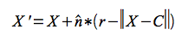
This was much more stable, and allowed for animation of a moving sphere.

Results:
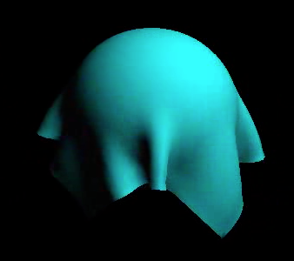
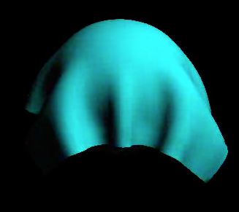
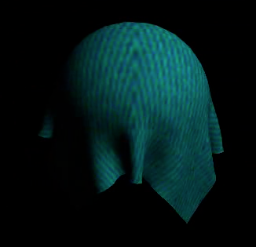
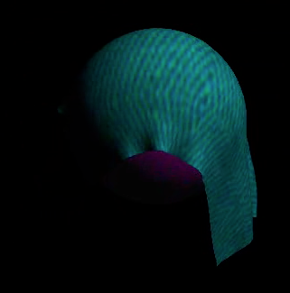

These are frames from cloths being draped over a sphere with two different stiffness values.

These are two frames from the same animation of a textured cloth falling on a sphere and then slipping off.

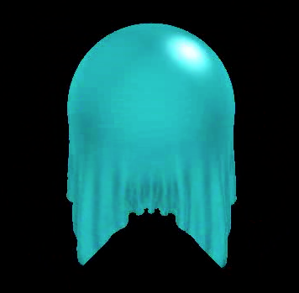

This is a frame from a high resolution cloth being draped over a sphere.
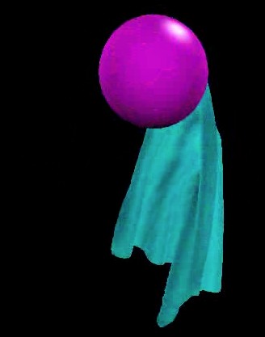
This is a frame from an animation of a cloth falling off of a sphere with a smaller time step increment.

